SPRINT 3

|  |  |
| --- | --- |
| Date | 12 November 2022 |
| Team ID | PNT2022TMID33811 |
| Project Name | Project – Smart Farmer-IoT Enabled smart Farming Application |

Develop an application for the Smart farmer project using MIT App Inventor

Design the Modules, Configuring device and controlling motor

BLOCKS FOR THE MIT INVENTOR APP:

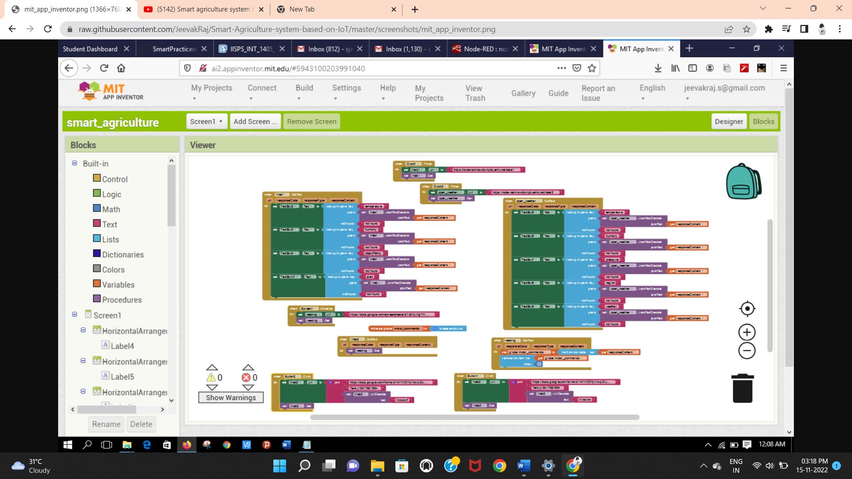

OPEN WEATHER UI

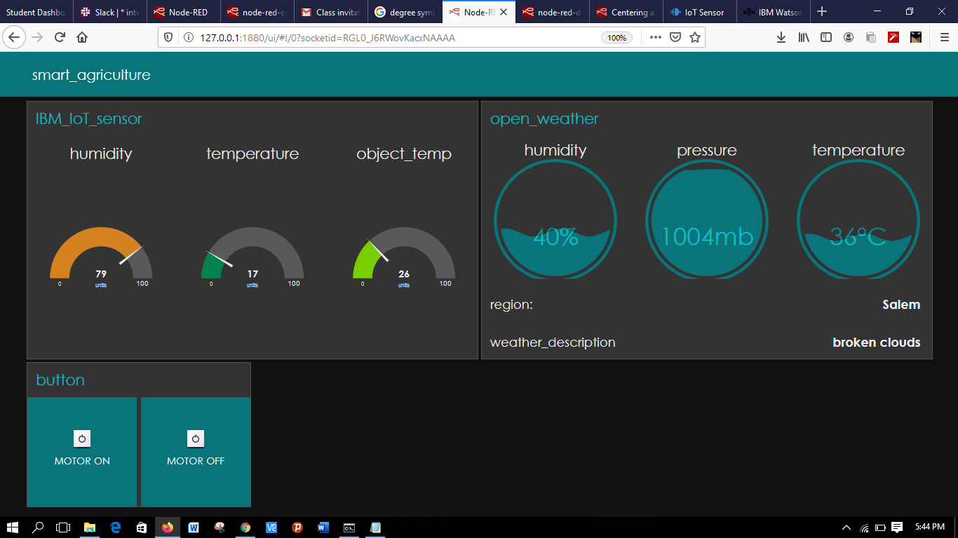

NODE RED CONNECTION COMMANDS:

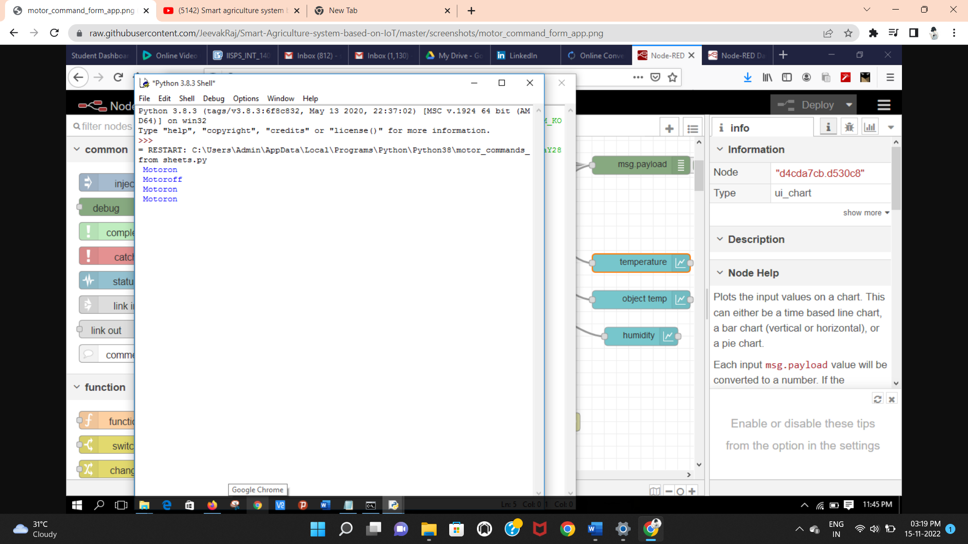

MOTOR COMMANDS:

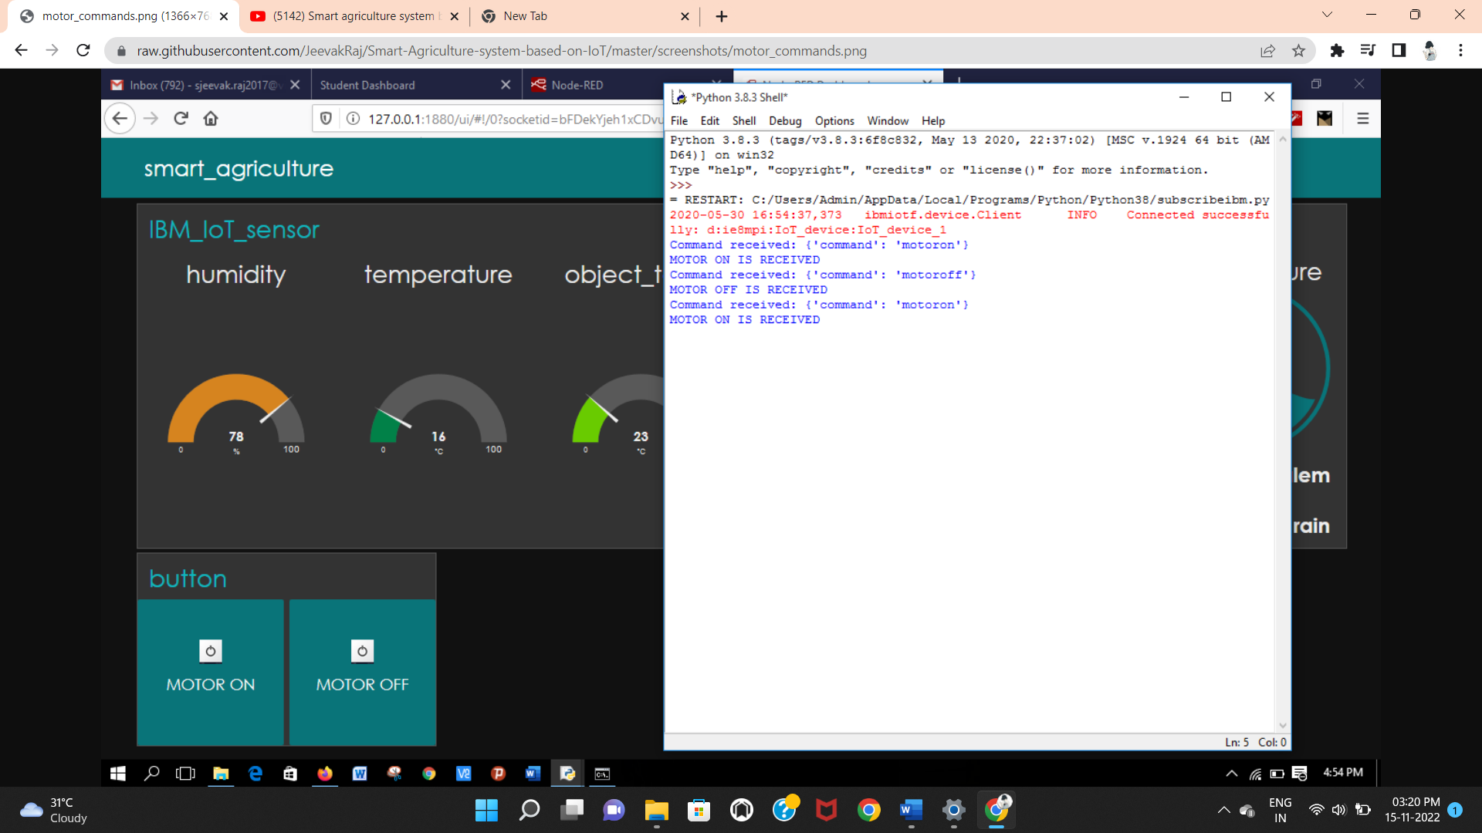

OPEN WEATHER CONNECTION CODE:

